# Conceptual Diagram

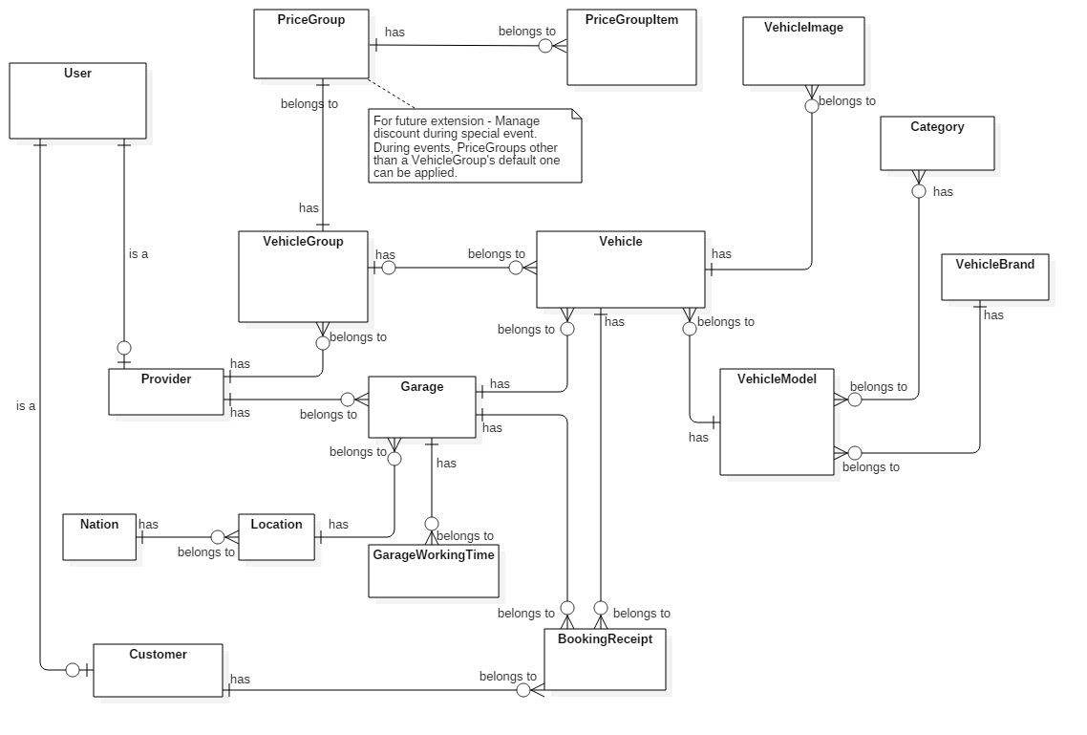

**Data Dictionary**

|  |  |
| --- | --- |
| Entity Data dictionary: describe all content of all entities | |
| Entity Name | **Description** |
| User | Abstract entity describes a user in system |
| Provider | Describe user with roles of provider in system |
| Customer | Describe user with roles of customer in system |
| Vehicle | Describe vehicle with basic information |
| VehicleImage | Contain images of vehicle |
| VehicleModel | Describe model of vehicle |
| VehicleBrand | Define brands of vehicle |
| Category | Describe types of vehicle |
| VehicleGroup | Describe a group of vehicle that have same configuration |
| PriceGroup | Configure price to rent for group of vehicle |
| PriceGroupItem | Describe detail price by hour for PriceGroup |
| Garage | Describe garage with basic information |
| GarageWorkingTime | Describe working schedule of garage in weekly |
| Location | Contain location of each Nation |
| Nation | List of Nation |
| BookingReceipt | Describe detail of a receipt after booking a vehicle |

# Class Diagram

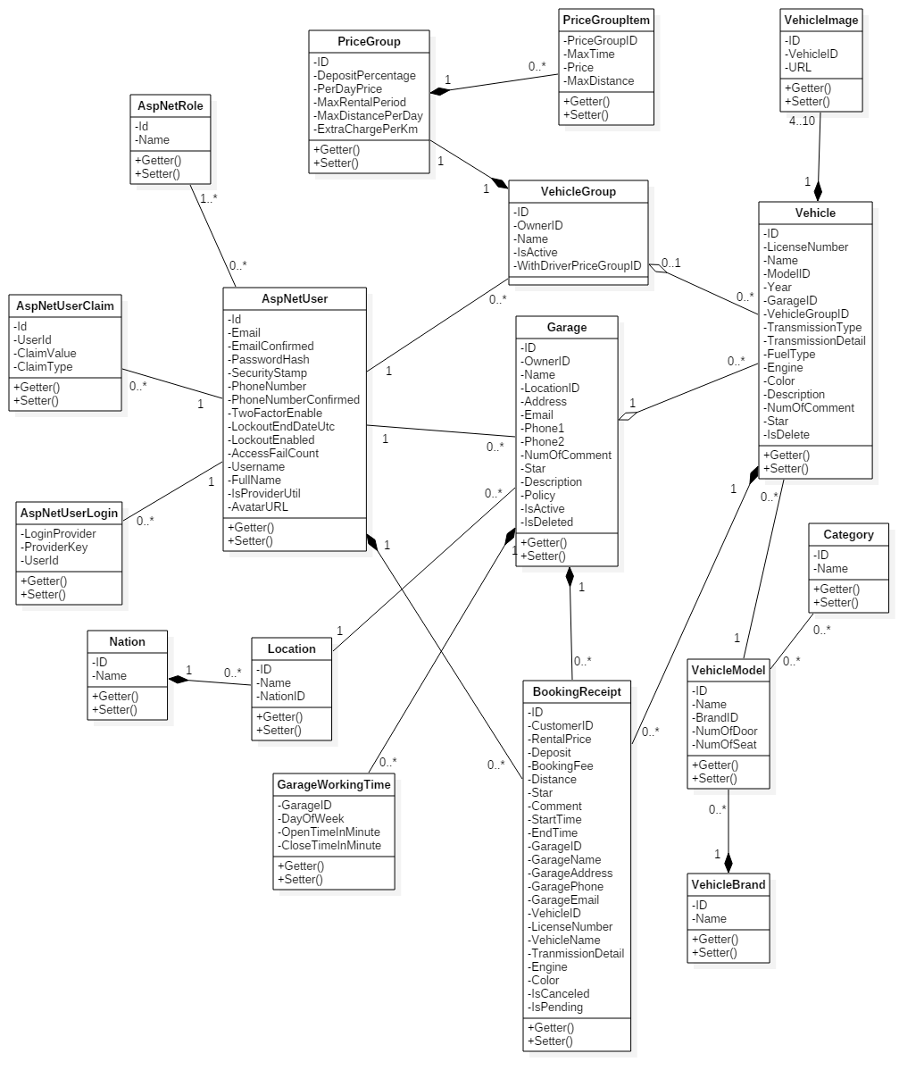

|  |  |  |
| --- | --- | --- |
| Class dictionary: Describe Class | | |
| Class Name | **Mapping column with Conceptual diagram** | **Description** |
| AspNetUser | User | Describe all user in system |
| AspNetRole | N/A | Define user’s roles |
| AspNetUserClaim | N/A | Contain a set of claims about user |
| AspNetUserLogin | N/A | Contain information about 3rd party/external logins |
| Vehicle | Vehicle | Describe all vehicle in system |
| VehicleImage | VehicleImage | Describe all vehicle’s images link in system |
| VehicleModel | VehicleModel | Describe all model of vehicle in system |
| VehicleBrand | VehicleBrand | Describe all brand of vehicle in system |
| Category | Category | Describe all type of vehicle in system |
| VehicleGroup | VehicleGroup | Describe all group to contain vehicle in system |
| PriceGroup | PriceGroup | Describe all config about rental that following by VehicleGroup in system |
| PriceGroupItem | PriceGroupItem | Describe all detail price for PriceGroup in system |
| Garage | Garage | Describe all garage in system |
| GarageWorkingTime | GarageWorkingTime | Describe all working schedule that following by Garage in system |
| Location | Location | Describe all location base on Nation in system |
| Nation | Nation | Describe all Nation in system |
| BookingReceipt | BookingReceipt | Describe all receipt in system |

# Class Diagram Explaination

1. AspNetUser

**Attributes**

|  |  |  |  |
| --- | --- | --- | --- |
| **Attribute** | **Type** | **Visibility** | **Description** |
| Id | String | Private | Unique identifier of AspNetUser |
| Email | String | Private | Email of user |
| EmailConfirmed | Boolean | Private | Check email is verified or not |
| PasswordHash | String | Private | User’s password after encoding |
| SecurityStamp | String | Private |  |
| PhoneNumber | String | Private | User’s phone number |
| PhoneNumberConfirmed | Boolean | Private | Check phone number is verified or not |
| TwoFactorEnabled | Boolean | Private |  |
| LockoutEndDateUtc | Nullable<DateTime> | Private |  |
| LockoutEnable | Boolean | Private |  |
| AccessFailedCount | Integer | Private | Count number of access failed |
| UserName | String | Private | User name in system |
| FullName | String | Private | User’s full name |
| IsProviderUntil | Nullable<DateTime> | Private | Period of providership |
| AvatarURL | String | Private | User’s avatar |

**Methods**

|  |  |  |  |
| --- | --- | --- | --- |
| **Method** | **Return type** | **Visibility** | **Description** |
| Getter | Attribute type | Public | Get attribute value |
| Setter | Void | Public | Set value of attribute |

1. AspNetRole

**Attributes**

|  |  |  |  |
| --- | --- | --- | --- |
| **Attribute** | **Type** | **Visibility** | **Description** |
| Id | String | Private | Unique identifier of AspNetRole |
| Name | String | Private | Name of role |

**Methods**

|  |  |  |  |
| --- | --- | --- | --- |
| **Method** | **Return type** | **Visibility** | **Description** |
| Getter | Attribute type | Public | Get attribute value |
| Setter | Void | Public | Set value of attribute |

1. AspNetUserClaim

**Attributes**

|  |  |  |  |
| --- | --- | --- | --- |
| **Attribute** | **Type** | **Visibility** | **Description** |
| Id | Integer | Private | Unique identifier of AspNetUserClaim |
| UserId | String | Private | Claim belongs to user who has this UserId |
| ClaimType | Stirng | Private | Type of claim |
| ClaimValue | String | Private | Value of claim |

**Methods**

|  |  |  |  |
| --- | --- | --- | --- |
| **Method** | **Return type** | **Visibility** | **Description** |
| Getter | Attribute type | Public | Get attribute value |
| Setter | Void | Public | Set value of attribute |

1. AspNetUserLogin

**Attributes**

|  |  |  |  |
| --- | --- | --- | --- |
| **Attribute** | **Type** | **Visibility** | **Description** |
| LoginProvider | String | Private |  |
| ProviderKey | String | Private |  |
| UserId | String | Private |  |

**Methods**

|  |  |  |  |
| --- | --- | --- | --- |
| **Method** | **Return type** | **Visibility** | **Description** |
| Getter | Attribute type | Public | Get attribute value |
| Setter | Void | Public | Set value of attribute |

1. Vehicle

**Attributes**

|  |  |  |  |
| --- | --- | --- | --- |
| **Attribute** | **Type** | **Visibility** | **Description** |
| ID | String | Private | Unique identifier of Vehicle |
| LicenseNumber | String | Private | License number of vehicle |
| Name | String | Private | Name of vehicle |
| ModelID | Integer | Private | Model of vehicle |
| Year | Integer | Private | vehicle is produced in year |
| GarageID | Integer | Private | The garage contain vehicle |
| VehicleGroupID | Nullable<Integer> | Private | Group that vehicle belong to |
| TransmissionType | Integer | Private | Transmission type of vehicle |
| TransmissionDetail | String | Private | Describe detail about transmisson of vehicle |
| FuelType | Nullable<Integer> | Private | Fuel type of vehicle |
| Engine | String | Private | Describe engine of vehicle |
| Color | Integer | Private | Color of vehicle |
| Description | String | Private | Provider’s description about vehicle |
| NumOfComment | Integer | Private | Number of customer’s feedback |
| Star | Decimal | Private | Rating of vehicle |
| IsDeleted | Boolean | Private | Check vehicle is deleted by provider |

**Methods**

|  |  |  |  |
| --- | --- | --- | --- |
| **Method** | **Return type** | **Visibility** | **Description** |
| Getter | Attribute type | Public | Get attribute value |
| Setter | Void | Public | Set value of attribute |

1. VehicleImage

**Attributes**

|  |  |  |  |
| --- | --- | --- | --- |
| **Attribute** | **Type** | **Visibility** | **Description** |
| ID | String | Private | Unique identifier of image returned by cloudinary |
| VehicleID | Integer | Private | The vehicle has this image |
| URL | String | Private | URL to access image on cloudinary |

**Methods**

|  |  |  |  |
| --- | --- | --- | --- |
| **Method** | **Return type** | **Visibility** | **Description** |
| Getter | Attribute type | Public | Get attribute value |
| Setter | Void | Public | Set value of attribute |

1. VehicleModel

**Attributes**

|  |  |  |  |
| --- | --- | --- | --- |
| **Attribute** | **Type** | **Visibility** | **Description** |
| ID | Integer | Private | Unique identifier of AspNetRole |
| Name | String | Private | Name of role |
| BrandID | Integer | Private | Brand has this model |
| NumOfDoor | Integer | Private | Number of door |
| NumOfSeat | Integer | Private | Number of seat |

**Methods**

|  |  |  |  |
| --- | --- | --- | --- |
| **Method** | **Return type** | **Visibility** | **Description** |
| Getter | Attribute type | Public | Get attribute value |
| Setter | Void | Public | Set value of attribute |

1. VehicleBrand

**Attributes**

|  |  |  |  |
| --- | --- | --- | --- |
| **Attribute** | **Type** | **Visibility** | **Description** |
| ID | Integer | Private | Unique identifier of VehicleBrand |
| Name | String | Private | Name of brand |

**Methods**

|  |  |  |  |
| --- | --- | --- | --- |
| **Method** | **Return type** | **Visibility** | **Description** |
| Getter | Attribute type | Public | Get attribute value |
| Setter | Void | Public | Set value of attribute |

1. Category

**Attributes**

|  |  |  |  |
| --- | --- | --- | --- |
| **Attribute** | **Type** | **Visibility** | **Description** |
| ID | Integer | Private | Unique identifier of Category |
| Name | String | Private | Name of category |

**Methods**

|  |  |  |  |
| --- | --- | --- | --- |
| **Method** | **Return type** | **Visibility** | **Description** |
| Getter | Attribute type | Public | Get attribute value |
| Setter | Void | Public | Set value of attribute |

1. VehicleGroup

**Attributes**

|  |  |  |  |
| --- | --- | --- | --- |
| **Attribute** | **Type** | **Visibility** | **Description** |
| ID | Integer | Private | Unique identifier of VehicleGroup |
| OwnerID | String | Private | Provider has this group |
| Name | String | Private | Name of group |
| IsActive | Boolean | Private | Status of group |
| WithDriverPriceGroupID | Integer | Private | Group of defination about rental |

**Methods**

|  |  |  |  |
| --- | --- | --- | --- |
| **Method** | **Return type** | **Visibility** | **Description** |
| Getter | Attribute type | Public | Get attribute value |
| Setter | Void | Public | Set value of attribute |

1. PriceGroup

**Attributes**

|  |  |  |  |
| --- | --- | --- | --- |
| **Attribute** | **Type** | **Visibility** | **Description** |
| ID | Integer | Private | Unique identifier of PriceGroup |
| DepositPercentage | Decimal | Private | Deposit before rent a vehicle |
| PerDayPrice | Double | Private | Price to rent a vehicle in 1 days |
| MaxRentalPeriod | Nullable<Integer> | Private | Maximum of days customer can rent a vehicle |
| MaxDistancePerDay | Nullable<Integer> | Private | Maximum distance customer can travel in 1 days |
| ExtraChargePerKm | Nullable<Double> | Private | Extra charge in 1 km when distance is over MaxDistancePerDay |

**Methods**

|  |  |  |  |
| --- | --- | --- | --- |
| **Method** | **Return type** | **Visibility** | **Description** |
| Getter | Attribute type | Public | Get attribute value |
| Setter | Void | Public | Set value of attribute |

1. PriceGroupItem

**Attributes**

|  |  |  |  |
| --- | --- | --- | --- |
| **Attribute** | **Type** | **Visibility** | **Description** |
| PriceGroupID | Integer | Private | This item belong to PriceGroup has this ID |
| MaxTime | Integer | Private | Maximum time can travel |
| Price | Double | Private | Price of item |
| MaxDistance | Integer | Private | Maximum distance can travel |

**Methods**

|  |  |  |  |
| --- | --- | --- | --- |
| **Method** | **Return type** | **Visibility** | **Description** |
| Getter | Attribute type | Public | Get attribute value |
| Setter | Void | Public | Set value of attribute |

1. Garage

**Attributes**

|  |  |  |  |
| --- | --- | --- | --- |
| **Attribute** | **Type** | **Visibility** | **Description** |
| ID | Integer | Private | Unique identifier of Garage |
| OwnerID | String | Private | Provider has this garage |
| Name | String | Private | Name of garage |
| LocationID | Integer | Private | Location of garage |
| Address | String | Private | Address of garage |
| Email | String | Private | Email to contact with garage |
| Phone1 | String | Private | Default phone number of garage |
| Phone2 | String | Private | Secondary phone number of garage |
| NumOfComment | Integer | Private | Number of customer’s feedback about vehicles in garage |
| Star | Decimal | Private | Rating of garage |
| Description | String | Private | Provider’s description about garage |
| Policy | String | Private | Policy of garage |
| IsActive | Boolean | Private | Status of garage |
| IsDeleted | Boolean | Private | Check garage is deleted by provider |

**Methods**

|  |  |  |  |
| --- | --- | --- | --- |
| **Method** | **Return type** | **Visibility** | **Description** |
| Getter | Attribute type | Public | Get attribute value |
| Setter | Void | Public | Set value of attribute |

1. GarageWorkingTime

**Attributes**

|  |  |  |  |
| --- | --- | --- | --- |
| **Attribute** | **Type** | **Visibility** | **Description** |
| GarageID | Integer | Private | Schedule belong to garage has this ID |
| DayOfWeek | Integer | Private | A day of week |
| OpenTimeInMinute | Integer | Private | Garage’s open time in DayOfWeek |
| CloseTimeInMinute | Integer | Private | Garage’s close time in DayOfWeek |

**Methods**

|  |  |  |  |
| --- | --- | --- | --- |
| **Method** | **Return type** | **Visibility** | **Description** |
| Getter | Attribute type | Public | Get attribute value |
| Setter | Void | Public | Set value of attribute |

1. Location

**Attributes**

|  |  |  |  |
| --- | --- | --- | --- |
| **Attribute** | **Type** | **Visibility** | **Description** |
| ID | Integer | Private | Unique identifier of Location |
| Name | String | Private | Name of location |
| NationID | Integer | Private | Nation has this location |

**Methods**

|  |  |  |  |
| --- | --- | --- | --- |
| **Method** | **Return type** | **Visibility** | **Description** |
| Getter | Attribute type | Public | Get attribute value |
| Setter | Void | Public | Set value of attribute |

1. Nation

**Attributes**

|  |  |  |  |
| --- | --- | --- | --- |
| **Attribute** | **Type** | **Visibility** | **Description** |
| ID | Integer | Private | Unique identifier of Location |
| Name | String | Private | Name of nation |

**Methods**

|  |  |  |  |
| --- | --- | --- | --- |
| **Method** | **Return type** | **Visibility** | **Description** |
| Getter | Attribute type | Public | Get attribute value |
| Setter | Void | Public | Set value of attribute |

1. BookingReceipt

**Attributes**

|  |  |  |  |
| --- | --- | --- | --- |
| **Attribute** | **Type** | **Visibility** | **Description** |
| ID | Integer | Private | Unique identifier of BookingReceipt |
| CustomerID | String | Private | Receipt belong to customer |
| RentalPrice | Double | Private | Total price of rental |
| Deposit | Double | Private | Deposit before rental |
| BookingFee | Double | Private | Booking fee |
| Distance | Nullable<Integer> | Private | Maximum distance can travel |
| Star | Nullable<Integer> | Private | Rating for rented vehicle |
| Comment | String | Private | Feedback for rented vehicle |
| StartTime | DateTime | Private | When rental is started |
| EndTime | DateTime | Private | When rental is ended |
| GarageID | Integer | Private | Receipt belong to garage |
| GarageName | String | Private | Name of garage at booking moment |
| GarageAddress | String | Private | Address of garage at booking moment |
| GaragePhone | String | Private | Phone of garage at booking moment |
| GarageEmail | String | Private | Email of garage at bookinh moment |
| VehicleID | Integer | Private | Receipt belong to vehicle |
| LicenseNumber | String | Private | Vehicle’s License number at booking moment |
| VehicleName | String | Private | Name of vehicle at booking moment |
| TransmissionDetail | String | Private | Vehicle’s transmission detail at booking moment |
| Engine | String | Private | Vehicle’s engine at booking moment |
| Color | Integer | Private | Color of vehicle at booking moment |
| IsCanceled | Boolean | Private | Check booking is canceled by customer |
| IsPending | Boolean | Private | Check booking is pending for payment |

**Methods**

|  |  |  |  |
| --- | --- | --- | --- |
| **Method** | **Return type** | **Visibility** | **Description** |
| Getter | Attribute type | Public | Get attribute value |
| Setter | Void | Public | Set value of attribute |